**Assignment 15**

**KD1-Indrajeet-86641**

Q1. Assume there is a table called Multicust, with all of the same column definitions as Salespeople. Write a command that inserts all salespeople with more than one customer into this table.

🡺 **Create table Multicust as select * from salespeople where snum in (select**

**snum from customers group by snum having count(snum)>1 );**

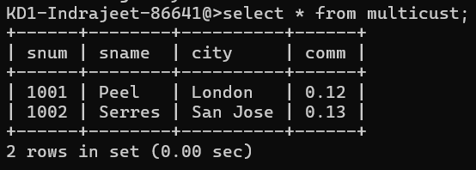

Q2. Write a command that deletes all customers with no current orders.

🡺 **delete from customers where cnum not in(select cnum from orders);**

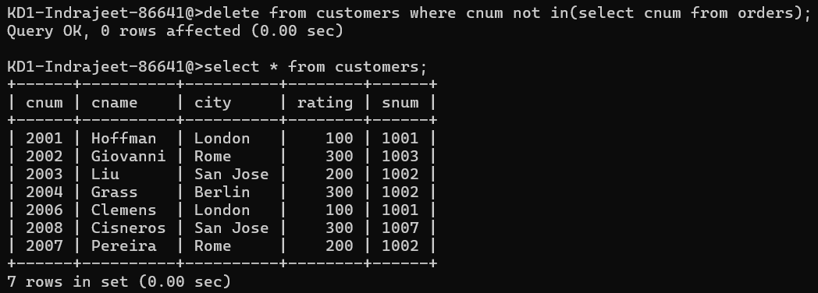

Q3. Write a command that increases by twenty percent the commissions of all salespeople with total orders above Rs. 3,000.

🡺 **update salespeople set comm=comm*1.20 where snum in (select snum**

**from orders where amt>300);**

